Car Dealership Management System (CDMS)
Web Technologies — Assignment 3 (Phase 1)
MUKUNZI Jonathan — 27132
GitHub Repository: [ PASTE LINK HERE ]
Video Walkthrough (Google Vid): [ PASTE LINK HERE ]

1. Abstract
The Car Dealership Management System (CDMS) is a web-based platform for managing the core operations of a car dealership: vehicle inventory, customer records, employee records, and sales transactions. It also models Rwanda's full administrative location hierarchy (Province → District → Sector → Cell → Village), used to locate customers and employees precisely rather than as free-text addresses. The system is built with a normalized relational schema, DTO-based validated input/output, and enforces data integrity through unique constraints, foreign-key relationships, and Bean Validation.

2. Problem Statement
Small and mid-sized dealerships in Rwanda typically track inventory, customers, and sales using spreadsheets or paper records. This leads to duplicate customer entries, no single source of truth for stock levels, inconsistent location data (free-text addresses that don't match administrative boundaries), and no reliable way to trace which employee closed which sale, or which cars were part of a multi-vehicle transaction. There is no centralized, queryable, validated system tying these together.

3. Scope of the Project

In scope
- Managing cars (add, update, delete, list, filter by brand, sort/paginate)
- Managing customers and employees, each linked to a precise administrative location
- Managing the Rwanda location hierarchy as a self-referencing tree (Province → Village)
- Recording sales linking a customer, an employee, and one or more cars
- Validation at UI, business-logic, and database level

Out of scope
- Payment gateway integration (payment method is recorded, not processed)
- Inventory forecasting / demand prediction
- Multi-dealership / franchise management

4. AS-IS Model
Currently, dealership staff record customer details, car stock, and sales manually or in disconnected spreadsheets, with no validation and no relational integrity between records:
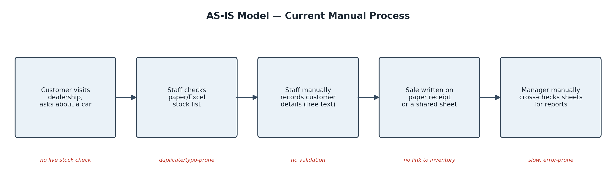

5. TO-BE Model
The proposed system centralizes all records in a validated, relationally-enforced flow, from inquiry through to reporting:
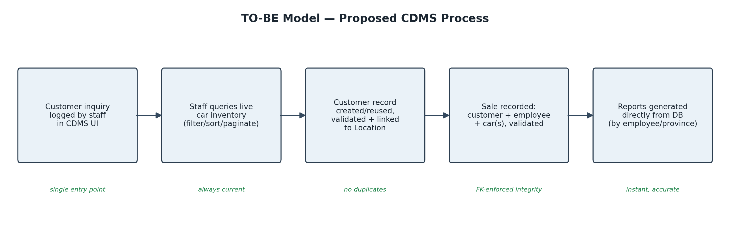

6. Business Requirements
- BR1: The system shall allow staff to add, view, update, and delete car records.
- BR2: The system shall allow staff to add, view, update, and delete customer records, each linked to a location.
- BR3: The system shall allow staff to add, view, update, and delete employee records, each linked to a location.
- BR4: The system shall allow staff to record a sale linking one customer, one employee, and one or more cars.
- BR5: The system shall prevent duplicate customers/employees (by email) and duplicate cars (by brand+model+year).
- BR6: The system shall validate all user input at the UI, business-logic, and persistence layers before committing data.
- BR7: The system shall allow filtering/searching of customers and employees by exact location or by province.
- BR8: The system shall support paginated and sorted listing of cars (by price, by year).

7. Software Qualities Applied
- Usability — clear forms with inline, field-level error messages
- Maintainability — layered architecture: model / DAO / bean / view, entities never exposed directly to the view
- Data Integrity — unique constraints, FK constraints, Bean Validation annotations on every entity
- Security — server-side validation is authoritative; client-side JS validation is a UX layer only, never trusted alone
- Scalability — pagination on car listings; self-referencing location tree scales to any administrative depth
- Performance — indexed lookups by location and by province via JPQL

8. Initial Class Diagram
All five entities and their relationships (Location's self-referencing tree, Customer/Employee → Location, Sale → Customer/Employee, Sale ↔ Car many-to-many):
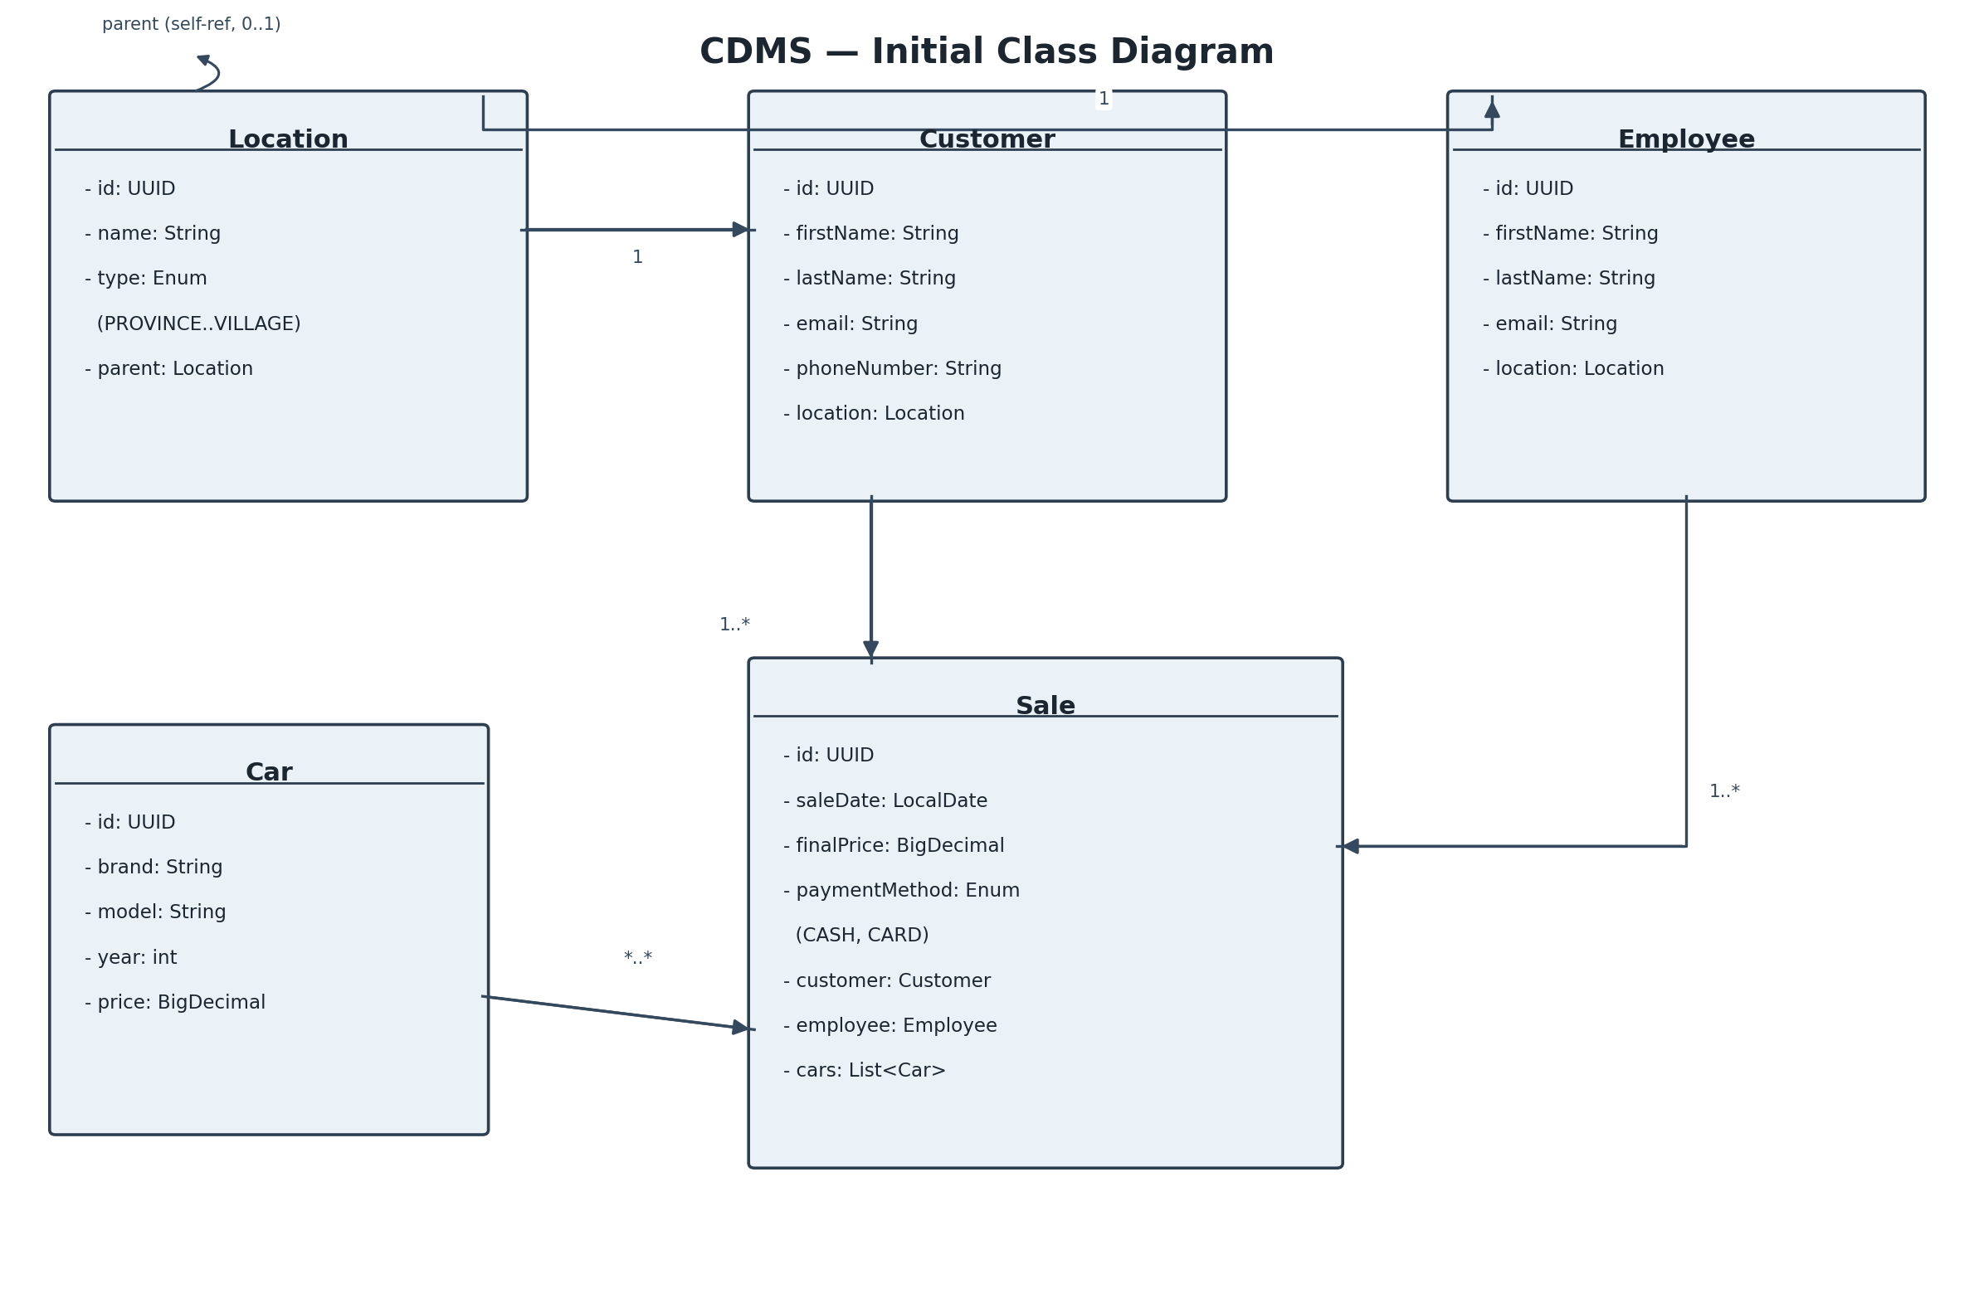

9. Practical Implementation (Part 2 of the Assignment)
Entities chosen for full CRUD via JSF + Hibernate: Car and Customer.
- Validation type 1 — JSF built-in validators (e.g. f:validateLongRange on Car.year)
- Validation type 2 — Bean Validation (Jakarta/JSR-380 annotations on the entity classes: @NotBlank, @Email, @DecimalMin, @Pattern), enforced automatically on every bound input
- Validation type 3 — Client-side JavaScript validation on form submit, as a first line of feedback before server round-trip
- CSS: external stylesheet (resources/css/styles.css), internal (<style> block in each .xhtml <h:head>), and inline (style attribute on individual elements)
See the GitHub repository (link above) for full source, and the linked video for a walkthrough of the working CRUD screens and the project's overall workflow.

